Ayush Goyal 190905522
CSE D Roll 62

Distributed Systems Week 3: Lab 3: Python Basic Practice-III

Lab Exercise Programs for Week 3:

1. Write a program to find the factors of a given number (get input from user) using for loop.

import numpy as np

x = int(input("Enter the number : "))
A = np.array([1])
for i in range(2, x+1):
if x%i == 0:
A = np.append(A, i)
print(A)

Output:

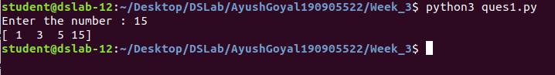

2. Find the sum of columns and rows using axis.

import numpy as np

A = np.array([[1, 2, 3], [4, 5, 6], [7, 8, 9]])
print(A)
rowSum = np.sum(A, axis = 1)
print('Row Sum is ', rowSum)
colSum = np.sum(A, axis = 0)
print('Column Sum is ', colSum)

Output:

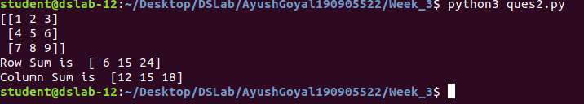

3. Operations on Arrays[use numpy wherever required):
a. Create array from list with type float
b. Create array from tuple
c. Creating a 3x4 array with all zeros
d. Create a sequence of integers from 0 to 20 with steps of 5
e. Reshape 3x4 array to 2x2x3 array
f. Find max and min element of array, row wise max and min, column wise max and min and sum of elements. (Use function max(), min(), sum()).

import numpy as np

x = [float(i) for i in input().split()]
A = np.array(x)
print(A)
t = tuple([float(i) for i in input().split()])
B = np.array(t)
print(B)
C = np.zeros((3, 4))
print(C)
D = np.reshape(C, (2, 2, 3))
print(D)
E = np.arange(0, 20, 5)
print(E)
F = np.array([[1, 2, 3], [4, 5, 6], [7, 8, 9]])
print(np.min(F, axis=1), np.min(F, 0), np.max(F, 1), np.max(F, 0), np.sum(F, 1), np.sum(F, 0))

Output:

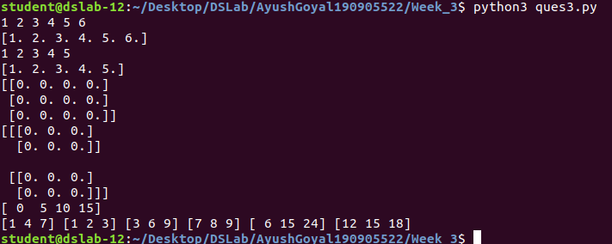

4. Write a program to transpose a given matrix.

import numpy as np
F = np.array([[1, 2, 3], [4, 5, 6], [7, 8, 9]])
print(np.transpose(F))

Output:

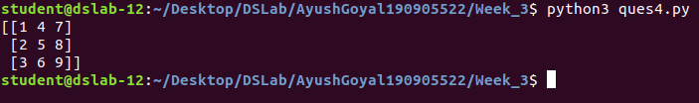

5. Write a program to add two matrices.

import numpy as np

F = np.array([[1, 2, 3], [4, 5, 6], [7, 8, 9]])
D = np.array([[1, 4, 7], [2, 5, 8], [3, 6, 9]])

print(F+D)

Output:

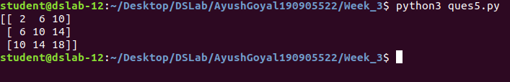

6. Write a program to find element wise product between two matrices.

import numpy as np

F = np.array([[1, 2, 3], [4, 5, 6], [7, 8, 9]])
D = np.array([[1, 4, 7], [2, 5, 8], [3, 6, 9]])

print(F*D)

Output:

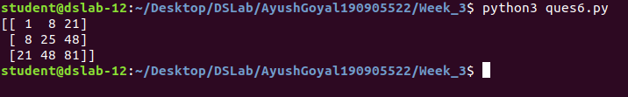

THE END

